February

Kindness Counts!
Sunday | Monday | Tuesday | Wednesday | Thursday | Friday | Saturday
 |  |  |  |  | 1 | 2
 |  |  |  |  | Bucket Fillers, book read on announcements  Do a Quick Write | Help with dishes
3 | 4 | 5 | 6 | 7 | 8 | 9
Read a book to someone today. | Make a new friend today! | Kindness Counts Kick off Assembly | Toothpaste lesson on how words can not be taken back. | Be kind to someone today! | Write a kind-o-gram to someone in your family. | Give someone a hug today!
10 | 11 | 12 | 13 | 14 | 15 | 16
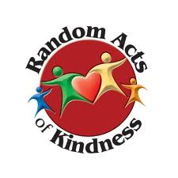  Help clean up your room today. | Lend a pencil to someone who needs one. | ABC’s of kindness class book. | Smile at someone today. | Add different ways your class can be kind to the “Kindness Wall”. | Speak kindly to EVERYONE! | Encourage someone today.
17 | 18 | 19 | 20 | 21 | 22 | 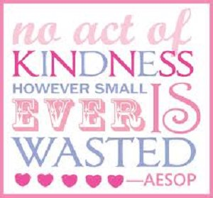  23
week | ------------Mid-Winter Break --------– No School------------
24 | 25 | 26 | 27 | 28
Open the door for someone today. | Do something kind when no one is looking. | Make a Class Kindness Quilt. | Smile at a teacher today. | Watch a kindness video  Blood Drive | Give someone a compliment today. | Believe in the MAGIC of kindness.

